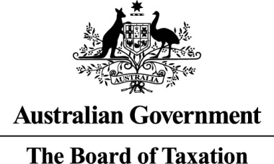

The Board of Taxation

2019-2020 Annual Report

©Commonwealth of Australia 2021

ISSN 2204‑0951 (print)  
ISSN 2204‑096X (web)

This publication is available for your use under a [Creative Commons BY Attribution 3.0 Australia](http://creativecommons.org/licenses/by/3.0/au/deed.en) licence, with the exception of the Commonwealth Coat of Arms and all third party material as attributed in this document. The full licence terms are available from <http://creativecommons.org/licenses/by/3.0/au/legalcode>.

CC by_grey

Use of Board of Taxation material under a [Creative Commons BY Attribution 3.0 Australia](http://creativecommons.org/licenses/by/3.0/au/deed.en) licence requires you to attribute the work (but not in any way that suggests that the Board of Taxation endorses you or your use of the work).

**Board of Taxation material used ‘as supplied’**

Provided you have not modified or transformed Board of Taxation material in any way including, for example, by changing the Board of Taxation text; calculating percentage changes; graphing or charting data; or deriving new statistics from published Board of Taxation statistics — then Board of Taxation prefers the following attribution:

*Source: Board of Taxation, 2019‑20 Annual Report. The Commonwealth of Australia does not necessarily endorse the content of this publication.*

**Derivative material**

If you have modified or transformed Board of Taxation material, or derived new material from those of the Board of Taxation in any way, then Board of Taxation prefers the following attribution:

*Based on the Board of Taxation, 2019‑20 Annual Report. The Commonwealth of Australia does not necessarily endorse the content of this publication.*

**Use of the Coat of Arms**

The terms under which the Coat of Arms can be used are set out on the Department of the Prime Minister and Cabinet website (see [www.pmc.gov.au/government/commonwealth‑coat‑arms](http://www.pmc.gov.au/government/commonwealth-coat-arms)).

**Other uses**

Enquiries regarding this licence and any other use of this document are welcome at:

Manager

Communications

The Treasury

Langton Crescent, Parkes ACT 2600

Email: [medialiaison@treasury.gov.au](mailto:medialiaison@treasury.gov.au)

A copy of this document appears on the Board of Taxation website:   
<http://www.taxboard.gov.au>.

Contents

[Contact details v](#_Toc67495827)

[Glossary of terms vi](#_Toc67495828)

[2019‑20 Highlights vii](#_Toc67495829)

[Introduction from the Chair 1](#_Toc67495830)

[Introduction from the Interim CEO 2](#_Toc67495831)

[1 The Board 4](#_Toc67495832)

[1.1 The Board’s mission and function 4](#_Toc67495833)

[1.2 Board members 5](#_Toc67495834)

[2 Activities of the board in 2019‑20 11](#_Toc67495835)

[2.1 Overview 11](#_Toc67495836)

[2.2 Completed projects 11](#_Toc67495837)

[2.3 Commenced projects 14](#_Toc67495838)

[2.4 Ongoing work 14](#_Toc67495839)

[2.5 Stakeholder Communications and Engagement 17](#_Toc67495840)

[3 The year ahead 19](#_Toc67495841)

[4 Appendix A: The Board’s Charter 20](#_Toc67495842)

[4.1 The Charter 20](#_Toc67495843)

[5 Appendix B: Membership of the Board 22](#_Toc67495844)

[5.1 Terms of Board members 22](#_Toc67495845)

[6 Appendix C: Board Working Groups and Private Sector Secondments 23](#_Toc67495846)

[7 Appendix D: Attendance at events, conferences, workshops and discussion groups 24](#_Toc67495847)

[8 Appendix E: Attendance at Board meetings 25](#_Toc67495848)

[9 Appendix F: Members of the Board’s Advisory Panel 26](#_Toc67495849)

[10 Appendix G: Consultancies 28](#_Toc67495850)

[11 Appendix H: Financial Statements 29](#_Toc67495851)

List of tables

[Table 1: Attendance at Board meetings, 2019‑20 10](#_Toc67495473)

[Table 2: Term of Board members 22](#_Toc67495474)

[Table 3: Membership of Board Working Groups, 2019‑20 23](#_Toc67495475)

[Table 4: Secondments from the private sector, 2019‑20 23](#_Toc67495476)

[Table 5: External events attended by Board members 24](#_Toc67495477)

[Table 6: Attendance at Board meetings, 2019‑20 25](#_Toc67495478)

[Table 7: Members of Advisory Panel as at 30 June 2020 26](#_Toc67495479)

[Table 8: Revenue, expenses and operating result 29](#_Toc67495480)

[Table 9: Remuneration paid to non‑government Board members, 2019‑20 29](#_Toc67495481)

# Contact details

Inquiries regarding this report may be directed to:

Board of Taxation Secretariat

c/o — The Treasury

Langton Crescent

PARKES ACT 2600

Telephone: 02 6263 4366

Email: [taxboard@treasury.gov.au](mailto:taxboard@treasury.gov.au)

# Glossary of terms

|  |  |
| --- | --- |
| AO | Order of Australia — Officer of the Order |
| AM | Order of Australia — Member of the Order |
| AASB | Australian Accounting Standards Board |
| APRA | Australian Prudential Regulatory Authority |
| ATO | Australian Taxation Office |
| BDO | Binder Dijker Otte |
| BEPS | Base Erosion and Profit Shifting |
| The Board | The Board of Taxation |
| CEO | Chief Executive Officer |
| EY | Ernst & Young |
| MAC | Ministerial Advisory Council |
| OECD | Organisation for Economic Co‑operation and Development |
| OPC | Office of Parliamentary Counsel |
| PwC | PricewaterhouseCoopers |
| PSM | Public Service Medal |

# 2019‑20 Highlights

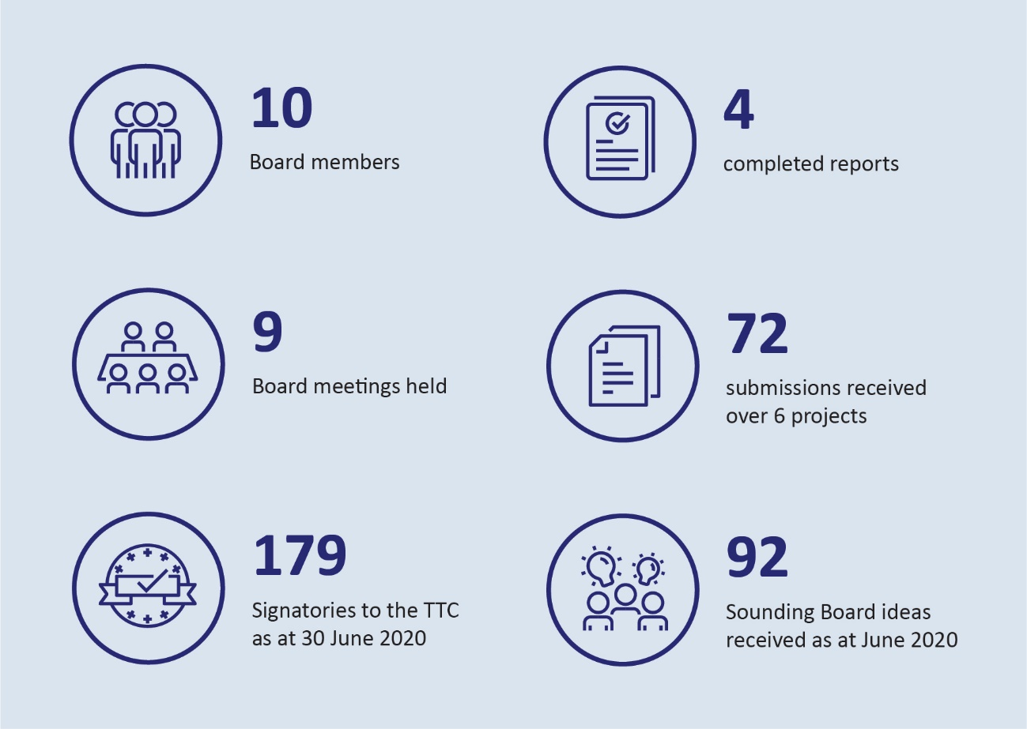

# Introduction from the Chair

On behalf of the Board of Tax (the Board), I am pleased to present our 2019‑2020 Annual Report.

I would like to acknowledge at the outset the contribution of our previous Acting Chair, Dr Julianne Jaques, who demonstrated remarkable leadership of the Board during the first half of this period after the sudden and sad passing of Michael Andrew AO in June 2019. I also acknowledge our newest Member, Mr Chris Vanderkley, who brings over 30 years’ of experience in the field of taxation in the financial services sector. All existing members continued to make consistent, high calibre contributions to improving the tax system and I wish to congratulate them for their efforts.

The past year was a challenging year for all, with a devastating bush fire season preceding the COVID‑19 pandemic and the most severe economic shock in Australia since the Great Depression. These challenges brought a somewhat changed focus for the Board. We delivered real‑time intelligence to the Government, Treasury and the ATO on the ‘lived experience’ of the tax and business community through the crisis, and provided tax policy and administrative proposals to cushion the economic impact. We have also continued our traditional role in undertaking in‑depth reviews of various aspects of the tax system finalising a number of them and continuing or beginning work on others.

The Board adapted quickly to the changed operating environment and, throughout this period, maintained a busy program of virtual engagement with stakeholders. I held an extensive series of virtual meetings with leaders of business, the tax profession and the broader community. On behalf of the Board, I wish to express my appreciation for the input, assistance and open engagement of our various stakeholders throughout the past year. Their contributions have been crucial to the Board continuing to fulfil its mission during this difficult period.

I, and my fellow Board members, look forward to a productive year ahead as we assist the Government navigate Australia’s economic recovery from COVID‑19. The Board will provide regular updates of its activites and encourages stakeholders to stay connected to the Board by subscribing via the Board’s website (<http://taxboard.gov.au>).

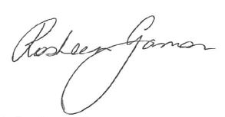

Rosheen Garnon

Chair, Board of Taxation

# Introduction from the Interim CEO

The 2019‑20 reporting period was a significant year for the Board. 2019’s highlights included the Government announcing (on 12 December 2019) the release of four Board reports:

* Reforming Individual Tax Residency Rules: a model for modernisation
* Review of Small Business Tax Concessions
* Introducing Asset Merger Rollover Relief
* Income Tax Treatment of Certain Forms of Deferred Consideration.

These reports represent a valuable contribution to public debate and the Government advised that it will continue to consider the implications of the Board’s findings.

We received significant support from stakeholders in the form of hospitality for hosting our Board meetings across Australia; we acknowledge KPMG, Deloitte, Baker McKenzie, BDO, and CA ANZ. We are grateful for this support and we look forward to working with all of our key stakeholders in the coming year.

The Board began 2020 by marking a significant milestone and holding its 200th Board meeting, which took place in Melbourne on 21 February 2020. This proved to be the last in‑person meeting for 2020. The Board quickly adapted to the health and economic crisis caused by the COVID‑19 pandemic by conducting virtual meetings for the remainder of this reporting period. I pay tribute to the dedicated, agile and hard‑working Secretariat in assisting the Board to transition to this new operating environment. The Secretariat is staffed primarily by secondees from the ATO, the Treasury and the private sector (refer Appendix C) and the Board thanks these organisations for their ongoing assistance with resourcing.

Notwithstanding the initial disruption in March, pleasingly, we were able to maintain our crucial engagement with stakeholders whilst COVID‑19 restrictions were in place by adopting virtual consultation sessions. Virtual consultations proved an efficient way to connect with stakeholders, not only on the Board’s traditional, longer‑term project work, but also for gathering real‑time information for the purposes of advising the Government on the economic impact on businesses during the crisis. This may represent a lasting improvement to the way in which the Board gathers real‑time intelligence to fulfil its mission going forward.

The Reports from several major reviews were completed and submitted to Government during the 2019‑20 reporting period. These included:

* Review of the corporate tax residency rules
* Review of FBT compliance costs
* Review of Granny flat arrangements
* Post‑implementation review of the Tax Transparency Code.

I, and the Secretariat, look forward to assisting the Board continue to bring together the views of the business and wider tax community in order to deliver credible advice to the Government as it navigates Australia’s economic recovery from COVID‑19.

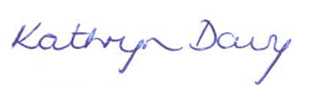

Interim CEO — Board of Taxation

# The Board

The Board of Taxation (the Board) is a non‑statutory advisory body charged with contributing a business and broader community perspective to improving the design of taxation laws and their operation.

During the 2019‑20 year, the Board was comprised of 10 members. Of these, 7 members were from the private sector plus 3 ex‑officio members (the Secretary to the Australian Treasury, the Commissioner of Taxation and the First Parliamentary Counsel).

The Board is supported by a small secretariat provided by the Treasury and supplemented with secondees from the private sector and the ATO.

Our Charter, including the Board’s mission, governs the operations of the Board and functions set out below. The Charter is reproduced in full at Appendix A.

## The Board’s mission and function

The Board provides an independent source of advice to government, from a business and broader community perspective, on taxation matters. In doing so the Board provides advice to the Treasurer and Minister for Housing and Assistant Treasurer on:

* the quality and effectiveness of tax legislation and the processes for its development, including the processes around community consultation and other aspects of tax design;
* improvements to the general integrity and functioning of the taxation system;
* research and other studies commissioned by the Board on topics approved or referred by the Treasurer; and
* other taxation matters referred to the Board by the Treasurer.

Our activities during the financial year ended 30 June 2020 are described more fully in Chapter 2.

## Board members

The Board comprises members appointed by the Treasurer. Private sector members are appointed in their personal capacity from within the business and wider community. The Secretary to the Australian Treasury, the Commissioner of Taxation and the First Parliamentary Counsel are *ex‑officio* members.

|  |
| --- |
| https://taxboard.gov.au/sites/taxboard.gov.au/files/2020-05/RGarnon-150x150_0.png  Rosheen Garnon — Chair  Mrs Garnon has over 30 years of experience in the field of taxation having been a senior partner with KPMG. She was admitted as a tax partner in 2000 and went on to hold senior executive roles with the firm.  From 2009 to 2015, Mrs Garnon was the National Managing Partner for KPMG Australia’s Taxation Division. She has extensive experience advising both domestic and global organisations.  Mrs Garnon’s background includes Bachelor of Economics (Accounting Major) and Bachelor of Laws from the Australian National University. She is a Fellow of Chartered Accountants in Australia and New Zealand, a Chartered Tax Advisor and a Graduate of the Australian Institute of Company Directors. She is also a member of Chief Executive Women.  Rosheen’s appointment as chair is for a 3 year period from 26 March 2020. |

|  |
| --- |
| Dr Julianne Jaques QC  Dr Julianne Jaques is a commercial barrister specialising in taxation and has over 25 years’ experience as a taxation professional. She maintains chambers in both Melbourne and Sydney and has appeared in all higher Federal, Victorian and New South Wales courts.  Dr Jaques is a Chartered Accountant and a Chartered Tax Adviser. She holds bachelor degrees in economics and law from Monash University and a Doctorate in Juridical Science from the University of Melbourne. Her doctoral thesis was on corporate taxation.  Dr Jaques is a part‑time member of the Independent Parliamentary Expenses Authority and the Tax Practitioners Board.  The Treasurer appointed Dr Jaques as Acting Chair of the Board from 11 July 2019 to 10 January 2020. |

|  |
| --- |
| Neville Mitchell  Mr Mitchell is a qualified Chartered Accountant with 27 years of experience (until March 2017) as Chief Financial Officer and Company Secretary of ASX‑listed Cochlear Limited, a world leading medical device developer, manufacturer and seller, with a market capitalisation of over $10bn.  Mr Mitchell is currently a non‑executive director of ASX‑listed Fisher & Paykel Healthcare, Sonic Healthcare and Osprey Medical, as well as privately owned Australian life sciences company, Q’Biotics Group. He is also a member of the Australian Board of Taxation and a director of the South East Sydney Local Health District Board.  Previously, he served on the New South Wales Medical Devices Fund, was Chairman of the Group of 100 (an Australian body for senior finance executives), and Chairman, Standing Committee (Accounting and Auditing), for the Australian Securities and Investments Commission (ASIC). |

|  |
| --- |
| Dr Mark Pizzacalla  Dr Pizzacalla is a Senior Partner with BDO in Melbourne Office. Dr Pizzacalla’s business experience, including acting as Managing Partner of his predecessor firm, gives him a strong appreciation of both the strategic and operational issues facing business and provides relevance to the technical tax advice he delivers.  Dr Pizzacalla completed his PhD in relation to the taxation of SMEs in Australia and is one of the few tax practitioners whose work has been cited in Australia’s Parliament. Dr Pizzacalla is also a member of The Tax Institute’s Victorian Technical Committee, and was previously the former Chair of The Tax Institute’s National SME Sub‑Committee, as well as being a former Victorian State Councillor.  Dr Pizzacalla was appointed to the Board in January 2015 and was reappointed for a further three year term commencing 1 January 2018. |

|  |
| --- |
| Ann‑Maree Wolff  Mrs Wolff has over 27 years’ experience as a qualified tax professional with over 17 years’ experience in senior tax roles within the mining industry. She is currently the Global Head of Tax for Rio Tinto responsible for all tax matters relevant to Rio Tinto.  Mrs Wolff is a Chartered Tax Advisor and Fellow of Chartered Accountants Australia and New Zealand.  Mrs Wolff was appointed to the Board in May 2015 and was reappointed for a further three year term commencing 14 May 2018. |

|  |
| --- |
| Craig Yaxley  Mr Yaxley is a senior tax partner with KPMG with over 35 years corporate tax experience including 25 years as a partner with KPMG Perth office. He provides tax advice to a wide range of international and Australian mining, oil and gas, mining services, property and agriculture clients on structuring inbound and outbound investments, financing, joint ventures and mergers and divestments.  Mr Yaxley is a Chartered Tax Advisor, Fellow of Chartered Accountants Australia & New Zealand, and member of AICD. He has been extensively involved in mining industry tax issues and policy developments in his previous role as Chairman of the Tax Committee for the Association of Mining and Exploration Companies Inc.  Mr Yaxley was appointed to the Board in January 2015 and was reappointed for a further three year term commencing 1 January 2018. |

|  |
| --- |
| Chris Vanderkley  Mr Vanderkley is currently Special Counsel at PwC leading their tax transparency and tax governance practice. He has over 30 years’ experience in the field of taxation, mainly within the financial services sector. Prior to joining PwC in 2016, he held senior positions at GE and GE Capital ANZ; including chief financial officer and Board member of most GE Australian entities from 2003 to 2016. In 1995 he was appointed Director of Taxation for GE ANZ; from 1998 to 2003 he was Director of Taxation for GE Capital Asia Pacific. His background includes a Graduate Diploma of Law (Taxation) from Monash University and a Bachelor of Business (Accounting, Law and IT) from Federation University.  Mr Vanderkley was appointed as a part‑time member for a 3 year period from 26 March 2020. |

|  |
| --- |
| Chris Jordan AO — Commissioner of Taxation  Mr Jordan was previously Chair of KPMG New South Wales and Partner in Charge of the New South Wales Tax and Legal Division of KPMG. He is the former Chair of the New Tax System Advisory Board and was also the State Chair of the New South Wales Division of the Taxation Institute of Australia. He was appointed by the NSW Government to the Games Advisory Committee of the Sydney 2009 World Masters Games.  Until his appointment as Commissioner of Taxation in January 2013, Mr Jordan was a member of the Sydney Children’s Hospital Foundation Board, the Board of the Bell Shakespeare Company, a member of the Audit Risk Committee of the Art Gallery of NSW and Chair of the Committee for Sydney.  Mr Jordan has been a member of the Board since its inception in September 2000. He was Deputy Chair from January 2005, was appointed to the position of Chair in June 2011 and retired from this position in December 2012 following his appointment as Commissioner of Taxation.  Mr Jordan has been an ex officio member of the Board since January 2013. |

|  |
| --- |
| Dr Steven Kennedy — Secretary to the Treasury  Dr Kennedy was appointed Secretary to the Treasury with effect from 2 September 2019.  Prior to his appointment as Treasury Secretary, Dr Kennedy was Secretary of the Department of Infrastructure, Transport, Cities and Regional Development between September 2017 and August 2019.  During his nearly 30 years in the public service, Dr Kennedy has held other senior positions including Deputy Secretary at the Department of the Prime Minister and Cabinet; Deputy Secretary at the Department of Industry, Innovation and Science; Deputy Secretary at the Department of the Environment; Deputy Secretary at the Department of Climate Change and Energy Efficiency, and the Head of Secretariat of the Garnaut Climate Change Review — Update 2011.  He is also the Institute of Public Administration Australia (IPAA) ACT President.  Dr Kennedy was awarded a Public Service Medal in 2016 for outstanding public service in the area of climate change policy. |

|  |
| --- |
| Peter Quiggin PSM, QC — First Parliamentary Counsel  Mr Quiggin is the First Parliamentary Counsel of the Office of Parliamentary Counsel (OPC), which is responsible for drafting all principal legislation, all regulations and a range of legislative instruments for the Australian Government, including taxation legislation. OPC is also responsible for the publication of Commonwealth legislation through the Federal Register of Legislation.  Mr Quiggin has been a drafter with the Office of Parliamentary Counsel for over 30 years and has drafted legislation covering a wide range of topics including taxation, native title and immigration.  Prior to working at OPC, Mr Quiggin worked for a number of years with the Tax Office and the Administrative Appeals Tribunal.  Mr Quiggin has been an ex officio member of the Board since January 2004.  Mr Quiggin was appointed a Commonwealth Queen’s Counsel on 15 October 2020. |

Table 1: Attendance at Board meetings, 2019‑20

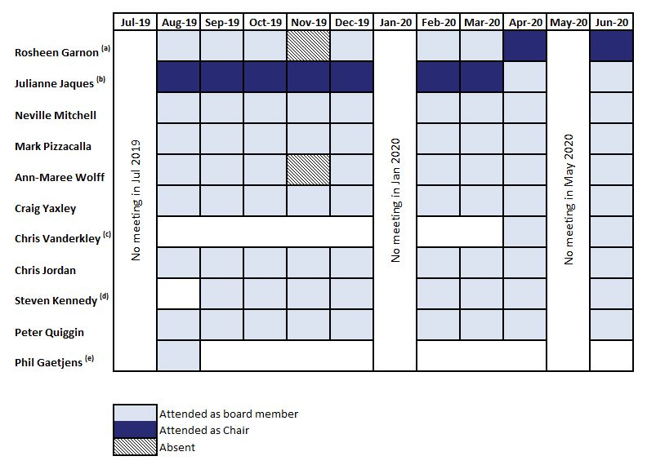

1. Mrs Garnon was appointed as Chair for a 3 year period from 26 March 2020.
2. Dr Jaques was appointed as Acting Chair of the Board from 11 July 2019 to 10 January 2020.
3. Mr Vanderkley was appointed as part‑time Member of the Board for a 3 year period from 26 March 2020.
4. Dr Kennedy was appointed Secretary to the Treasury with effect from 2 September 2019.
5. Mr Gaetjens was Secretary to the Treasury between 1 August 2018 and 30 August 2019.
6. The Board’s Charter allows for ex‑officio members of the Board to be represented by a delegate at Board meetings

# Activities of the board in 2019‑20

## Overview

The Board provides advice to government in relation to the taxation system through a number of ways. These include:

* Formal reports to government with Board recommendations
* Letters to the Treasurer, the Assistant Treasurer, Treasury and the ATO providing insights on areas of the tax system including in relation to emerging issues identified by the Board members through consultation with stakeholders
* Meetings with ministers to provide real time policy advice.

During 2019‑20 the Board completed four projects. Details on these projects are outlined below.

## Completed projects

### Post‑implementation review of the Voluntary Tax Transparency Code

At the request of the former Minister for Revenue and Financial Services, the Hon Kelly O’Dwyer MP, the Board commenced a post‑implementation review of the Voluntary Code to improve its content, usability and uptake.

The Board established a Working Group to undertake the review. Board members Mrs Ann‑Maree Wolff and Mr Neville Mitchell along with former Chair Mr Michael Andrew AO and Ms Karen Payne were appointed to oversee this review.

The Working Group conducted targeted consultations with different stakeholder groups to collect feedback on the Voluntary Code. These included business and industry groups, tax advisers, current signatories to the Voluntary Code, investor groups, financial analysts, and social justice groups.

The Board provided its report to Government in October 2019.

### Review of Granny Flat Arrangements

On 29 November 2018, the Australian Government announced that the Board would undertake a review of the tax treatment of granny flat arrangements. The request was partly made in response to the 2017 Australian Law Reform Commission’s (ALRC) report: *Elder Abuse — A National Legal Response.*

A granny flat arrangement is an increasingly common type of family arrangement under which an older Australian transfers title to their home, or proceeds from the sale of their home, to their adult child or another trusted person in return for the promise of ongoing housing and care. To ensure that the older person’s interests are protected, it is important that such arrangements are formal, written and legally enforceable. However, there was a concern that tax and social security implications were encouraging families to opt instead for loose, informal arrangements, leaving the older person at risk of financial abuse.

Over the course of the review, the Board consulted widely with experts in this area, including with members of the Elder Law and Succession Law Committee of the Law Council of Australia. The Board is very grateful for their insights, expertise and commitment of time.

The Board appointed a Working Group of its members led by Mr Craig Yaxley as chair, and Mr Neville Mitchell and Mr Peter Quiggin PSM to oversee this review. Former Member and CEO, Ms Karen Payne led the outset of the Review before being appointed as Inspector‑General of Taxation and Taxation Ombudsman.

The Board provided its report to Government in November 2019.

|  |
| --- |
| Additional Commentary  Review of Granny Flat Arrangements |
| The central tax issue in this report is that formal, more commercial‑type granny flat arrangements, as distinct from private and domestic promises, expose the families to a large capital gains tax liability. The Board found that tax implications were significant obstacle to the adoption of formal, legally enforceable agreements.  ***Encouraging Australians to enter granny flat arrangements with a level of formality and seriousness which they devote to other once‑in‑a‑lifetime financial arrangements may ultimately reduce instances of financial abuse and exploitation of older people.***  Our key recommendation is to provide exemptions for the various capital gain events that would otherwise arise over the life of a granny flat arrangement for all parties to the arrangement.  There are also other tax implications that may be acting as an impediment to formal granny flat arrangements. For instance, the adult child is at risk of losing part of their main residence CGT exemption when they later sell their home. Further complications may also arise when the older person pays regular rent‑type payments under the arrangement.  The Board’s report lays out the current policy and tax settings and makes recommendations to align the tax system with the government initiatives of protecting the rights of older Australians. We believe that the proposed tax reforms can help ensure that the interests of the older person are protected and minimising the risk of elder abuse. |

### Fringe Benefits Tax: Compliance Cost and International Practice Review

The Board commenced a review into the cost of compliance associated with Fringe Benefits Tax (FBT) obligations in 2018 following a request from the then Minister of Revenue and Financial Services, the Hon Kelly O’Dwyer MP.

The Board established a working group comprised of Board members, Mrs Rosheen Garnon (Chair) and Mr Neville Mitchell. The working group also included Ms Karen Payne (former Board member and CEO), Mr Tony Principe (Group of 100), Dr Binh Tran‑Nam (University of New South Wales) and officials from the Department of the Treasury (Treasury) and the Australian Taxation Office (ATO).

The Board provided its report to Government in October 2019.

|  |
| --- |
| Additional Commentary  Fringe Benefits Tax: Compliance Cost and International Practice Review |
| The Board sought to respond to the challenges of FBT reform from a solid evidentiary base and undertook an extensive data collection exercise involving focus groups, surveys, and in‑depth case study interviews of FBT taxpayers and tax advisers as well as international comparisons on the taxation of non‑cash employee benefits.  ***Reducing red tape and simplifying the operation of the FBT law will make a real difference to employers of all sizes in Australia***  At the time, the Board’s compliance cost research program was the most comprehensive, in‑depth study into FBT compliance costs ever conducted internationally.  The Board’s research results gave the Board excellent insight into a wide range of compliance cost and FBT issues, including the reasons employers provide fringe benefits, the direct and indirect costs of complying with FBT obligations, and most importantly, the drivers of compliance costs. |

### Tax Concessions for the Not‑For‑Profit Sector

The Board undertook a review of the tax concessions currently available to the Not‑For‑Profit sector in Australia to identify potential areas for improvement.

The Board established a Working Group to prepare this paper, comprising Board members Dr Julianne Jaques (Chair) and the late Mr Michael Andrew AO. The Working Group reviewed the reports issued by a number of reviews undertaken into this area in the past and consulted with Government departments and agencies (including the Treasury, the Australian Taxation Office (ATO), the ACNC and the Productivity Commission), with revenue authorities in Canada, New Zealand and the United Kingdom, and with a small number of private sector advisers.

The Board provided its report to Government in February 2020.

## Commenced projects

### Residency Rules for Companies

During the course of 2019‑2020 the Board undertook a review of corporate tax residency. The review involved assessing the current corporate tax residency rules and considering whether the existing rules are operating appropriately in light of modern, international and commercial board practices and international tax integrity rules.

The Board appointed a Working Group that included Board members Mr Neville Mitchell as chair of the working group. He was assisted by Dr Julianne Jaques, Mrs Ann‑Maree Wolff and Mr Chris Vanderkley.

Over 40 participants attended our roundtable consultations in Melbourne, Sydney and Perth. In addition, the Board received numerous written submissions and collected further feedback from private interviews with stakeholders.

The Board submitted its report to government in the 2020‑21 reporting period.

### Commenced Review of CGT roll‑over rules

In December 2019, the Minister for Housing and Assistant Treasurer, the Hon Michael Sukkar MP announced that the Board would undertake a review of capital gains tax roll‑over rules.

The Board was requested to identify and evaluate opportunities to rationalise the existing CGT rollovers and associated provisions into a simplified set that have a substantially similar practical effect, but are easier to use and interpret.

The Board established a working group for the review, comprising Mr Craig Yaxley (Chair), Mrs Ann‑Maree Wolff and Dr Mark Pizzacalla, representatives from the tax profession, academia, Treasury and the ATO.

Consultation was undertaken during February 2020 through to May 2020. The Board intends to submit its report to government in the 2020‑21 reporting period.

## Ongoing work

In addition to the individual projects the Board undertakes, the Board also has several ongoing tasks that fall within its remit. These tasks are outlined below.

### Regulatory reform

The Board continues to assist the Government in reducing the regulatory burden associated with taxation. This focus arose both because of the Board’s role as the Ministerial Advisory Council (MAC) for tax matters and from its general mandate to contribute to the improvement to the general integrity and functioning of the taxation system.

In fulfilling the MAC role, the Board is asked to:

* identify potential targets for regulatory reform (for example, areas of inefficient regulation, excessive red tape or unnecessarily high regulatory burden)
* provide a sounding board for regulatory reform or repeal proposals
* provide feedback on the progress of regulatory reform within the portfolio
* advise on broader policy issues relevant to the portfolio.

In particular, the Board is asked to provide appropriate input on:

* immediate deregulatory tasks, including the stocktake and audit of tax regulation
* future regulatory reforms, that is, ideas on deregulatory opportunities and priorities that can be included in the regulatory budgeting process.

During 2019‑20, the Board acted as a sounding board in relation to the ATO’s self‑assessed ratings against the Regulator Performance Framework.

A working group consisting of Board members Neville Mitchell and Craig Yaxley supported this work.

Additionally, the Board has an oversight function in relation to the exercise of the Commissioner’s remedial power. To fulfil this function, the Board has an opportunity to independently review the cases and to provide input before and after the private and public consultation processes. The Board was not called upon to review any cases in 2019‑20.

### Sounding Board

The Board utilises ‘Sounding Board’ to identify proposals for system improvement with a focus on red tape reduction and compliance savings. It is a web based collaborative platform where users can raise, debate and prioritise business and community sector ideas on how to improve the current tax system and replaces the previous Tax Issues Entry System.

At each of its regular meetings, the Board looks at all new ideas posted to Sounding Board. Where suitable, the Board will advocate a pathway for their implementation via legislative or administrative means.

To date ideas posted on Sounding Board have contributed to:

* initiating the review of fringe benefits tax compliance costs
* several ideas being considered as part of other Board reviews
* a change in law for excess superannuation contributions
* two ideas included in the Miscellaneous Amendments Bill Exposure Draft released for consultation on 6 September 2019
* several ideas being put forward to government as part of the Board’s Budget ideas submissions and other advice
* a number of ideas being referred to other government departments.

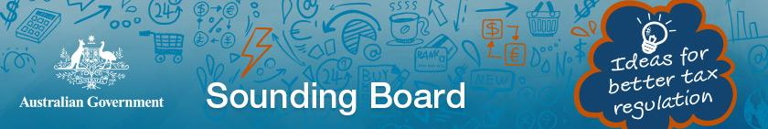

### Watching briefs

The Board maintains a watching brief on developments in the areas of:

* International developments in the taxation of the digital economy.
* Potential impacts on taxation laws from changes in accounting standards.

#### Digital Economy

The Board has been monitoring the work by the OECD to address the tax challenges raised by digitalisation and the steps being taken to develop a consensus‑based solution by the end of calendar year 2020. The Board is assisted by Treasury on this matter who provided a number of updates and presentations to the Board during the course of 2019‑20. Board member Craig Yaxley has led the Board’s work during the 2019‑20 period.

#### Changes to accounting standards

The Board has been monitoring the tax implications of changes in accounting standards. The Board undertakes this work by receiving updates from Treasury and the ATO as well as the wider tax and accounting community. Recently, the Board has been monitoring the implications for the tax system in respect of changes to the following accounting standards:

* AASB 15 Revenue from Contracts with Customers.
* AASB 16 Leases.
* AASB 17 Insurance Contracts.

A working group consisting of Board members Mr Craig Yaxley and Mrs Ann‑Maree Wolff support the Board’s work in this area.

## Stakeholder Communications and Engagement

The role of the Board is to be a trusted adviser to the Treasurer (and the government). The Board fulfils this role by providing a business perspective on taxation issues. Therefore, it strives to engage with the community on tax matters through a variety of different channels.

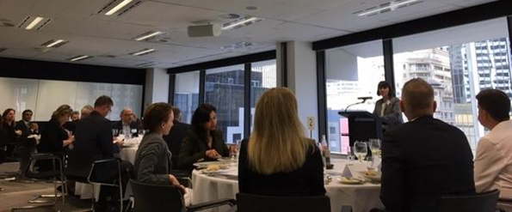For example, the Board meets regularly with stakeholders at each of its Board meetings to stay informed on current and emerging tax issues.

Dr Julianne Jaques (Acting Chair) addressing stakeholders at the Sydney Lunch (September 2019)

The Board utilises a working group model to conduct its reviews. As such, it reaches out to subject matter experts to become part of the working group for the duration of the project. During the course of a review, the working group may canvasses stakeholder views by conducting formal (and informal) consultation meetings, publishing consultation papers, calling for public submissions and surveys.

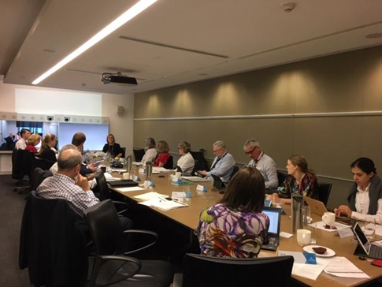

Mrs Rosheen Garnon speaking at the Not‑For‑Profit Stewardship Group

The most comprehensive set of information about the Board is contained on its website which can be found at: www.taxboard.gov.au. The website contains information on Board members, its Charter, contact details, press releases, published reports, and other activities currently being undertaken by the Board.

Stakeholders can be kept informed of the Board activities through its regular CEO Update newsletter which is produced following each Board meeting. To receive a copy of this newsletter stakeholders can subscribe to the Board’s website.

The Board also has a presence on LinkedIn and Twitter which it uses to advertise stakeholder events and call for submissions for reviews it is undertaking.

Ideas for tax system improvement can be submitted via Sounding Board which is a web based collaborate platform where uses can post and comment on ideas. Discussion of new ideas posted to Sounding Board are a standing item on the agenda at each Board meeting.

In 2020 the Board switched to virtual meetings for all collaboration tasks (including Board meetings and consultation sessions).

# The year ahead

As always, the Board will continue to provide proactive policy advice to the government on issues as they come to hand. Further, the Board will continue to action any other matters referred to the Board by Ministers during the course of the year ahead.

A key focus for the Board in 2020‑21 will be on economic recovery in a post‑COVID‑19 world. The Board will be working with government and the taxation community to develop measures that drive growth, increase productivity and reduce red tape.

In the year ahead, the Board will look to finalise the following projects that are underway as at 30 June 2020:

* Finalisation of the CGT rollovers report.
* Submission of corporate residency rules review report.

The Board will continue to adapt to operating in a post‑COVID‑19 world. This means operating virtually for Board meetings and stakeholder events where needed. The Board is keen to host virtual stakeholder engagement sessions and is looking forward to resuming face to face events if and when it is safe to do so.

On the international front, the Board will maintain a watching brief on developments on the taxation of the digital economy. Continued engagement with Treasury has been very much appreciated and the Board will be pleased to offer its insights on any proposed changes as events playout.

# Appendix A: The Board’s Charter

## The Charter

### Mission

Recognising the Government’s responsibility for determining taxation policy and the statutory roles of the Commissioner of Taxation and the Inspector General of Taxation, the Board’s mission is to contribute a business and broader community perspective to improving the design of taxation laws and their operation.

### Membership

Members of the Board will be appointed by the Treasurer, for a term of up to three years, on the basis of their personal capacity. It is expected that members will be appointed from within the business and wider community having regard to their ability to contribute at the highest level to the development of the tax system. The Chair will be appointed by the Treasurer from among these members of the Board. If the Treasurer decides to appoint a Deputy Chair, he or she will also be appointed from among these members of the Board. Members may be re appointed.

In addition, the Secretary to the Department of the Treasury, the Commissioner of Taxation and the First Parliamentary Counsel will also be members of the Board. Each may be represented by a delegate.

### Function

The Board will provide advice to the Treasurer on:

* the quality and effectiveness of tax legislation and the processes for its development, including the processes of community consultation and other aspects of tax design
* improvements to the general integrity and functioning of the taxation system
* research and other studies commissioned by the Board on topics approved or referred by the Treasurer
* other taxation matters referred to the Board by the Treasurer.

### Relationship to other boards and bodies

From time to time the Government or the Treasurer may establish other boards or bodies with set terms of reference to advise on particular aspects of the tax law. The Treasurer will advise the Board on a case by case basis of its responsibilities, if any, in respect of issues covered by other boards and bodies.

### Report

The Chair of the Board will report to the Treasurer, at least annually, on the operation of the Board during the year.

### Secretariat

The Board will be supported by a secretariat provided by the Treasury, but may engage private sector consultants to assist it with its tasks.

### Other

Members will meet regularly during the year as determined by the Board’s work program and priorities.

Non‑government members will receive remuneration and allowances to cover travelling and other expenses, at rates in accordance with Remuneration Tribunal determinations for part time public offices.

The Government will determine an annual budget allocation for the Board.

# Appendix B: Membership of the Board

## Terms of Board members

Table 2: Term of Board members

The term of the Board members is as follows:

|  |  |  |
| --- | --- | --- |
| Member | Term commenced | Term expires |
| Rosheen Garnon, Chair  (Board member) | 26 March 2020  1 January 2018 | 25 March 2023  25 March 2020  *(31 December 2020)* |
| Dr Julianne Jaques  (acting Chair until 10 January *‑ 11 July 2019 to 10 January 2020)* | 1 July 2017 | 30 June 2023 |
| Neville Mitchell | 14 May 2015 | 13 May 2021 |
| Dr Mark Pizzacalla | 1 January 2015 | 31 December 2020 |
| Chris Vanderkley | 26 March 2020 | 25 March 2023 |
| Ann‑Maree Wolff | 14 May 2015 | 13 May 2021 |
| Craig Yaxley | 1 January 2015 | 31 December 2020 |
| Phil Gaetjens | 1 August 2018 | 30 August 2019  — Ex‑officio |
| Dr Steven Kennedy | 2 September 2019 | Ex‑officio |
| Chris Jordan(a) AO | 1 January 2013 | Ex‑officio |
| Peter Quiggin PSM | 19 January 2004 | Ex‑officio |

(a) Chris Jordan AO has been a member of the Board in various capacities since 14 September 2000.

# Appendix C: Board Working Groups and Private Sector Secondments

Table 3: Membership of Board Working Groups, 2019‑20

Note: All working groups are supported by Government officials from other agencies in particular Treasury and the ATO.

Completed references, 2019‑20

|  |  |
| --- | --- |
| Fringe benefits tax compliance cost review | Review of the tax implications of granny flat arrangements |
| Rosheen Garnon (Chair) Neville Mitchell  Tony Principe Binh Tran‑Nam | Craig Yaxley (Chair)  Neville Mitchell Peter Quiggin PSM |

|  |  |
| --- | --- |
| Post‑implementation review of the voluntary tax transparency code | Not‑for‑profit sector tax issues |
| Ann‑Maree Wolff (Chair) Neville Mitchell Karen Payne | Dr Julianne Jaques (Chair)  Michael Andrew AO |

Broader work of the Board

|  |  |
| --- | --- |
| Corporate tax residency review | CGT roll‑over rules review |
| Neville Mitchell (Chair) Ann‑Maree Wolff  Dr Julianne Jaques | Craig Yaxley (Chair)  Ann‑Maree Wolff |

|  |  |
| --- | --- |
| Tax system improvement (Sounding Board) | Regulator performance framework (MAC) |
| Craig Yaxley Neville Mitchell Peter Quiggin PSM | Neville Mitchell (Chair)  Craig Yaxley |

|  |  |
| --- | --- |
| Watching briefs | |
| Alignment of tax and accounting | International developments digital tax |
| Craig Yaxley (Chair)  Ann‑Maree Wolff | Ann Maree Wolff Craig Yaxley |

Table 4: Secondments from the private sector, 2019‑20

|  |
| --- |
| EY — Vicky Lin, Manager, Melbourne |

# Appendix D: Attendance at events, conferences, workshops and discussion groups

In addition to the events hosted by the Board when it regularly meets, Board members also attended events, conference and discussions hosted by the organisations below.

Table 5: External events attended by Board members

|  |  |
| --- | --- |
| Organisations | Events |
| APPEA | Biennial Tax Conference |
| Institute of Public Accountants | Conference |
| Legalwise Seminar’s 5th Annual | Trusts Essentials Program |
| Taxation Institute | Victorian Tax Forum |
| Tax Institute of Australia | Board of Taxation roundtable |
| TaxBanter podcast | TaxYak |

# Appendix E: Attendance at Board meetings

Table 6: Attendance at Board meetings, 2019‑20

|  |  |  |
| --- | --- | --- |
| Member | Number of meetings eligible to attend | Number of meetings attended |
| Rosheen Garnon (Chair from 26 March 2020) | 9 | 8 |
| Dr Julianne Jaques (Acting Chair until 10 January) | 9 | 9 |
| Neville Mitchell | 9 | 9 |
| Dr Mark Pizzacalla | 9 | 9 |
| Chris Vanderkley | 2 | 2 |
| Ann‑Maree Wolff | 9 | 8 |
| Craig Yaxley | 9 | 9 |
| Dr Steven Kennedy | 8 | 8 |
| Phil Gaetjens | 1 | 1 |
| Chris Jordan AO | 9 | 9 |
| Peter Quiggin PSM | 9 | 9 |

1. The Board’s Charter allows for ex‑officio members of the Board to be represented by a delegate at Board meetings

# Appendix F: Members of the Board’s Advisory Panel

Table 7: Members of Advisory Panel as at 30 June 2020

| Panel Member | Position, Organisation |
| --- | --- |
| Michael Barbour | General Manager, Group Tax, Westpac |
| Paul Balkus | Co‑leader — Oceania Transfer Pricing, EY |
| Steve Baxter | Director, Mazars (NSW) Pty Limited |
| Patrick Broughan | Partner, Deloitte |
| Michael Carruthers | Tax Director, Knowledge Shop |
| Michael Croker | Tax Leader — Australia, CA ANZ |
| Jason de Boer | Tax Partner, BDO |
| Philip Diviny | Partner, Madgwicks Lawyers |
| Michael Fenner | Taxation Manager, Chevron |
| Mark Ferrier | Executive Director, Macquarie Group |
| Michael Flynn QC | Barrister, Victorian Bar |
| Geofrey Fooks | General Manager, Group Taxation, Wesfarmers |
| Steve Ford | Partner, PwC |
| Brett Freudenberg | Professor — Taxation, Griffith University |
| Heather Gray | Partner, Hall & Wilcox Lawyers |
| Kevin Griffiths | Leader Tax Division, EY |
| Tony Greco | General Manager, Institute of Public Accountants |
| Matt Hayes | Director — Tax, KPMG |
| Steve Healey | Partner, RSM Australia |
| Paul Hooper | Group Head of Tax, Lend Lease |
| Nick Houseman | Australian Transfer Pricing Leader, PwC |
| Peter Janetzki | Tax Partner, EY |
| Anthony Klein | Partner, PwC |
| Jasmine Leonard | General Manager — Global Tax Advisory, Rio Tinto |
| Adam Levin | Senior Consultant, Jackson McDonald Lawyers |
| Michael Longes | Tax Manager, Sunsuper Pty Ltd |
| Alia Lum | Partner, KPMG |
| James Macky | Partner, Corporate Tax, KPMG |
| Larry Magid | Consultant, Allens |
| Jane Michie | Head of Group Tax, BHP Billiton |
| Mark Molesworth | Tax Partner, BDO |

Table 7: Members of Advisory Panel as at 30 June 2020 (continued)

|  |  |
| --- | --- |
| Panel Member | Position, Organisation |
| Katrina Parkyn | Partner, King & Wood Mallesons |
| Michael Perez | Partner, King & Wood Mallesons |
| Dale Pinto | Professor of Taxation Law, Curtin Law School, Curtin University |
| Anthony Portas | General Manager Taxation, Rio Tinto |
| Tony Principe | Associate Director — Tax, ShineWing Australia |
| Brian Purdy | Head of Tax, South32 |
| John Rawson | Tax Partner, Deloitte |
| Premila Roe | Global Head of Tax, BHP Billiton |
| Hayden Scott | Tax Controversy Leader, PwC |
| Shannon Smit | Director, Transfer Pricing Solutions Asia |
| Steve Southon | Chief Tax Officer, NAB |
| Miranda Stewart | Professor of Law, University of Melbourne |
| Judy Sullivan | Partner, PwC |
| Paul Suppree | Assistant Director, Corporate Tax Association |
| Reynah Tang AM | Member, Victorian Civil and Administrative Tribunal |
| Vic Timos | Group Tax Manager, Incitec Pivot Limited |
| William Thompson | Director, Thompson Group |
| Coralie Trotter | Vice President Tax (Asia Pacific) Shell |
| Richard Vann | Challis Professor of Law, University of Sydney |
| Grant Wardell‑Johnson | Lead Tax Partner, KPMG Economics & Tax Centre |
| Steve Westaway | Partner, Director & Company Secretary, Grant Thornton |
| Sue Williamson | Partner, EY |
| Ken Woo | Partner, PwC |

# Appendix G: Consultancies

Consultants are engaged in accordance with Treasury’s policies for the engagement of consultants and contractors. These policies, which are consistent with the Chief Executive Instructions and the Commonwealth Procurement Guidelines, are outlined in the Treasury Annual Report.

### Consultants

In 2019‑20, Board of Taxation had one consultancy contract involving total actual expenditure of $72,600 (including GST).

# Appendix H: Financial Statements

Table 8: Revenue, expenses and operating result

|  |  |  |
| --- | --- | --- |
|  | **2018‑19** | 2019‑20 |
|  | **$** | $ |
| Revenue |  |  |
| Revenue — Department of the Treasury budget allocation | 1,854,557 | 1,610,642 |
| Revenue — Other | 455,869 | 542,243 |
| Total revenue | **2,310,426** | **2,152,885** |
| Expenses |  |  |
| *Employee expenses* |  |  |
| Wages | 701,583 | 601,542 |
| Superannuation | 180,769 | 157,983 |
| Other employee expenses | 583,971 | 507,497 |
| ***Total employee expenses*** | ***1,466,323*** | ***1,267,022*** |
| *Other expenses* |  |  |
| Travel | 150,828 | 87,674 |
| Conferences and training | 3,924 | 5,004 |
| Consultants and Contractors | 74,998 | 66,000 |
| Seconded Employees | 570,022 | 678,606 |
| Office supplies | 1,001 | 4 |
| Other supplier expenses | 43,330 | 48,575 |
| ***Total other expenses*** | ***844,103*** | ***885,863*** |
| Total expenses | **2,310,426** | **2,152,885** |
| Operating surplus | **‑** | **‑** |

Table 9: Remuneration paid to non‑government Board members, 2019‑20

|  |  |
| --- | --- |
| Board Members 2019‑20 | $ |
| **Total** | **$417,255** |